Introduction and working state of the assistant:

1. I have created a new Gen AI Bank Assistant as part of IBM track 2 challenge.
2. I have designed an assistant using IBM Watson x Gen AI tools which helps in banking customers with wide range of products and services.
3. This AI Assistant works helps in several tasks easily and advantage being it works 24/7 which means whenever there is a problem the assistant is available which is a major advantage for the bank using it.
4. This new Assistant offers help for customers by understanding their needs and recommends the necessary products and services.
5. Below is the Banking Assistant home screen that has been designed for use.

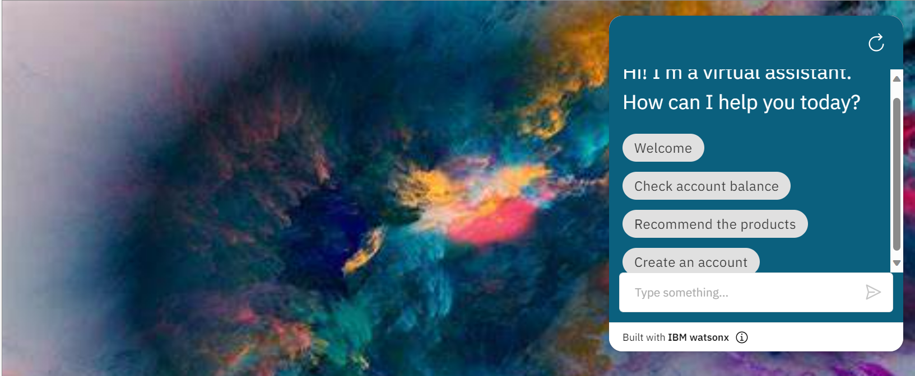

1. Let’s explore each section of this new assistant.

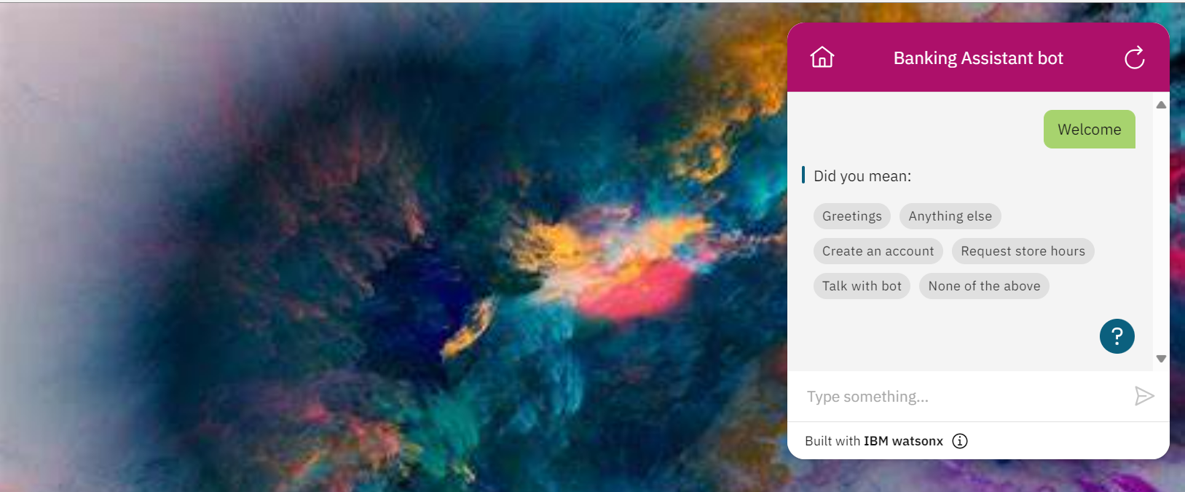

Figure : Welcomes you with range of services for the first time

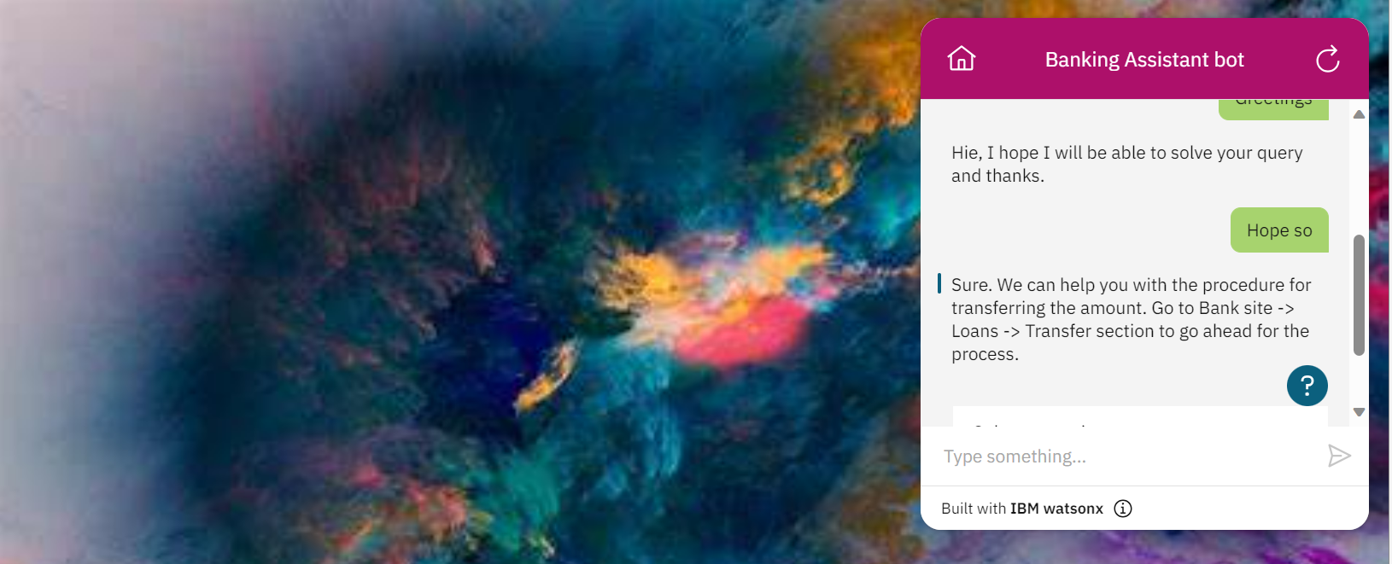

Figure : Accepts customer response and provides with options for selection

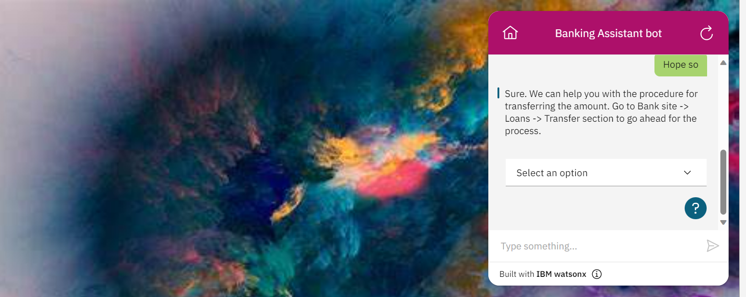

1. There are five options that are created at tis stage to select. They are Got it, Need further help, More details please, connect to bank agent and None of these.
2. Some of the recommendations it offers:

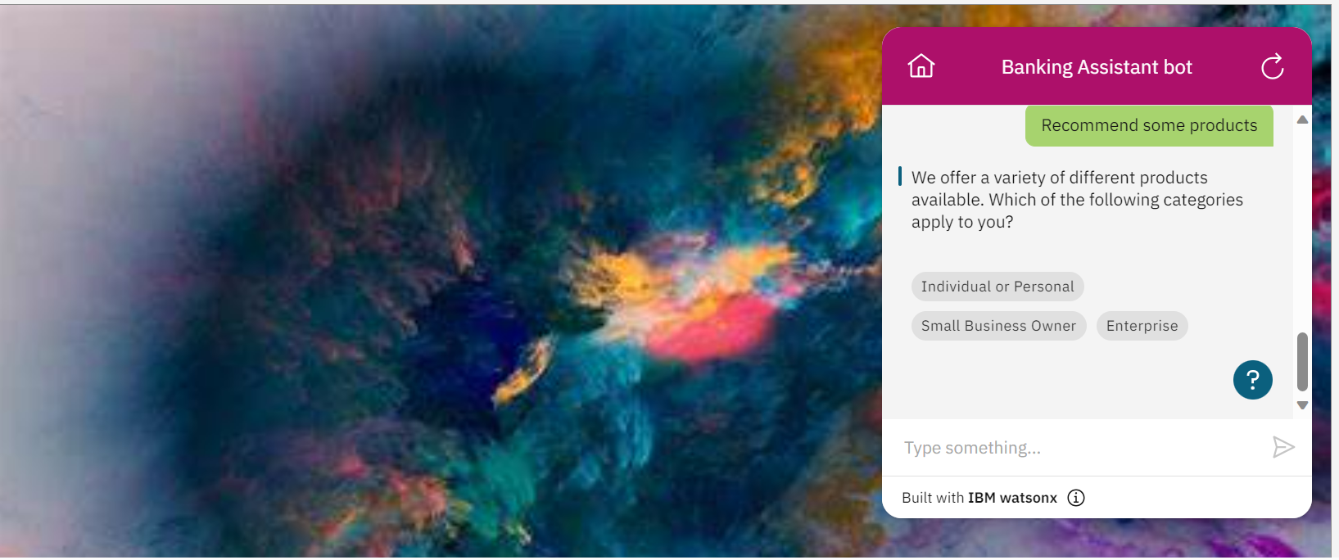

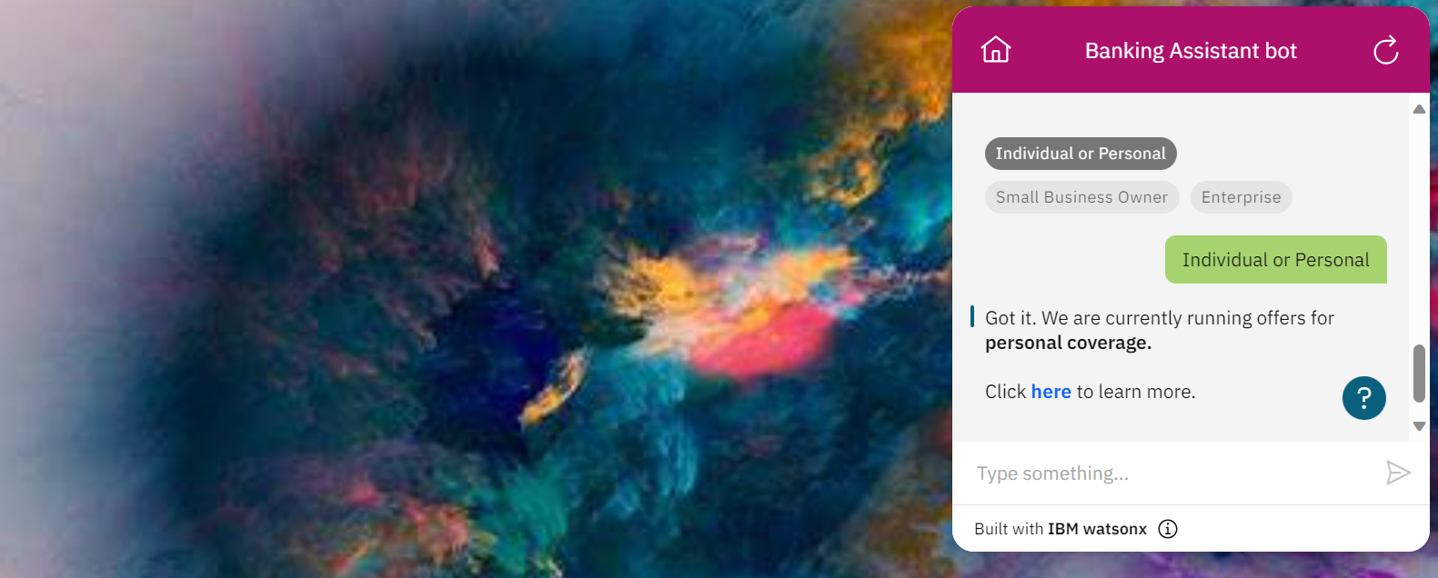

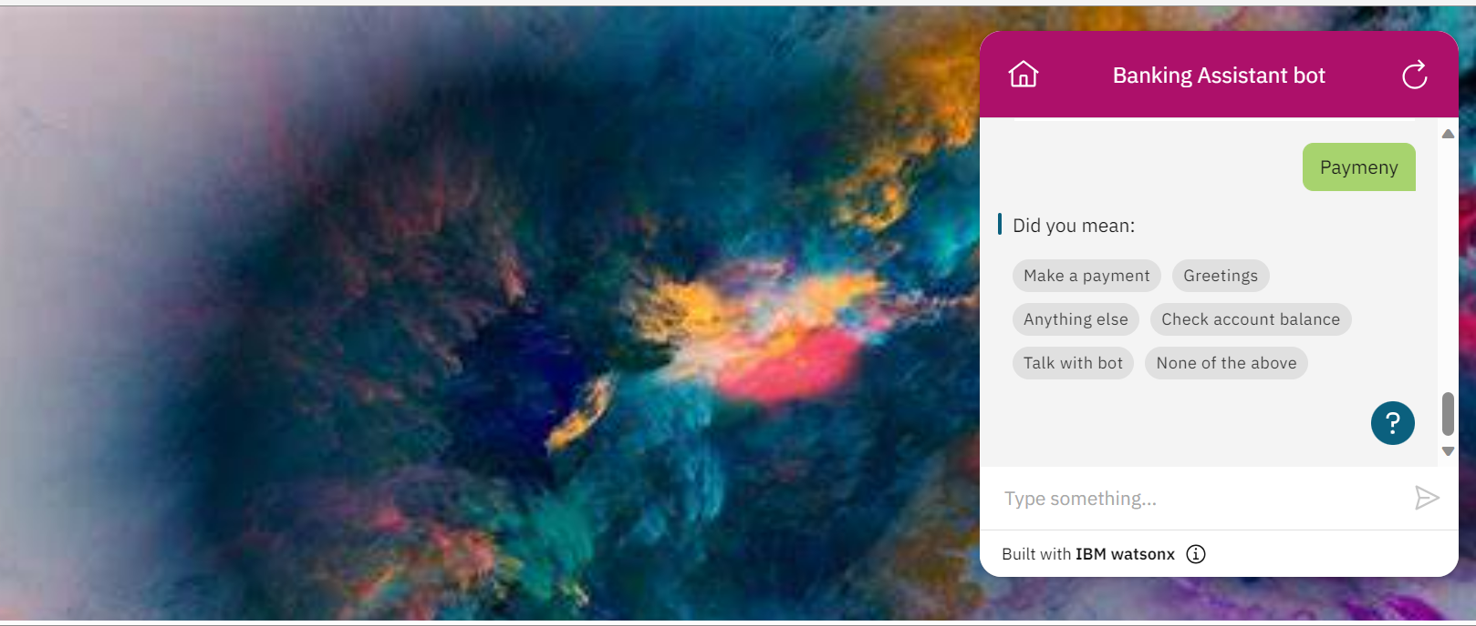

Figure : Discovering the mistake.

1. Even though there is some mistake it tries to redirect to the necessary location.
2. When you want to check the balance, it asks you some questions to clarify on user authentication to confirm it is whether it is the correct person just like a verification without which it is not going to provide you the bank account details.

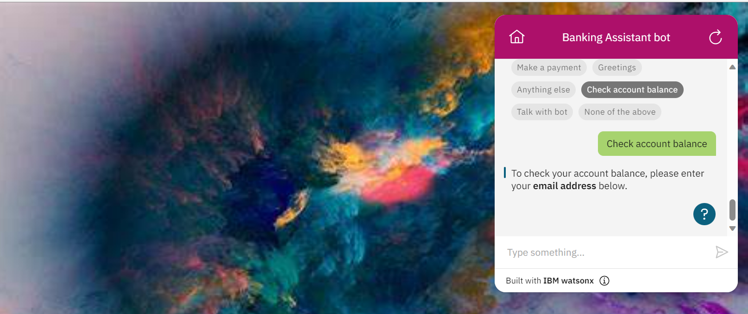

Figure : User authentication

1. You can even just talk to the bot as you do with a human and it is going to be super interactive.

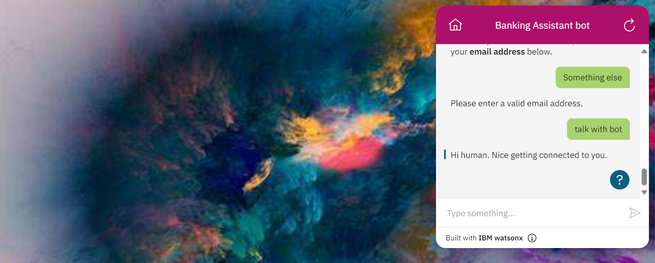

1. Here is the sign off from bot when user wants to end the conversation.

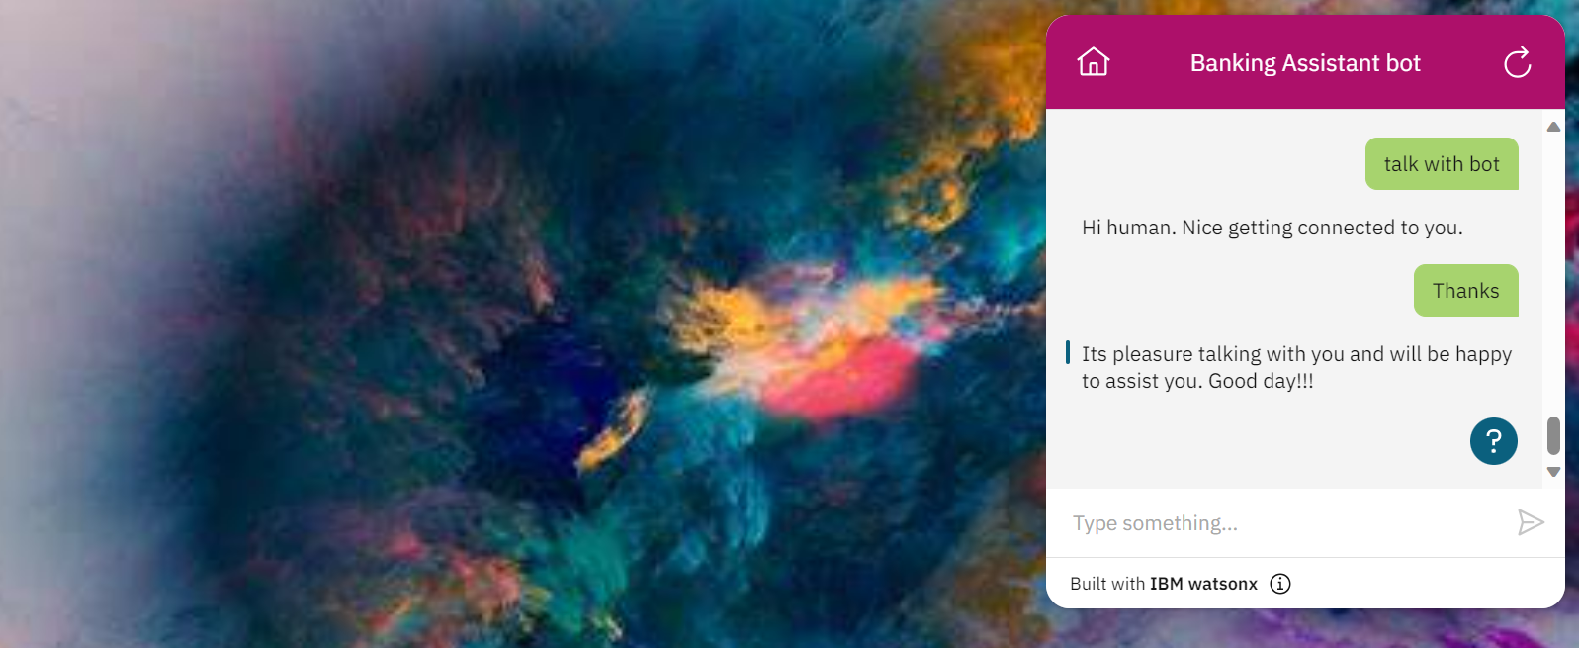

Use cases:

* Very useful for upcoming banking services
* Technology enthusiasts are going to cherish this service.
* This kind of service are go-to when it needs constant monitoring and support to avoid fraud and suspicious activities when users/bankers not available.
* Improves customer experience with the respective banks.
* Always communicates well with customers with no bias towards anything.

Endpoints:

* It is going to be super beneficial when all the necessary products and services can be used or can be known by just talking to this AI assistant.
* It is the future and capabilities of it are unimaginable and can achieve much more than expected or beyond the necessary.

Note: There are many more additions that can be made to this assistant, and it is due to the time constraint could not make much more.